Jessica Goldberg
Framing materials

My deepest apologies for the delay in my materials, especially as Jean Laurent has agreed to let me depart from our usual format and ask your help in another kind of intellectual task. So rather than presenting a paper in progress, I ask you all to use my time to help me think about the ways I might make use of an on-going but semi-orphaned digital humanities project and the tools they developed. Further, I thought it might be nice to introduce you to these tools and some of the problems in creating them, and get your thoughts on whether this might be a feasible way of approaching your own data sets. I am thus giving you a couple of things—1. a general public narrative overview I presented of my work that inspiring thinking about using the ChartEx tool; 2. A pdf of slides that present the ChartEx project in a very general way; 3. A ChartEx white paper that goes into way too much detail about the results of the project, but contains some helpful information about the concept and process. It would be helpful if you could look at the slides, and read pp. 10-16, 72-81 of the white paper. Skimming my public presentation will also help, I hope, give you a sense of how I came to think this tool could help me in my work.

My brief summary of the genesis of my request is this:
- First, my second book project, as initially conceived, asks how Genoese traders imagined the geography of their business, how this imagined geography changed in response to their expansion, or how in turn their ideas of what risks and opportunities various places represented influenced the trajectories of expansion. In service of this project, I spent a couple of years both digitizing the texts of Genoese cartularies in order to index the use of various expressions defining freedom of agents, and building a database to analyze the various destinations and itineraries of trade for the early period of Genoese expansion (in the mid-12th-early 13th century) using notarial cartularies, Genoa’s book of laws, and narrative sources. Collating my initial results led to somewhat unexpected conclusions. Discussing these with several like-minded scholars, especially Agostino Inguscio, who had been looking at the nature of family alliances, and shifting notions of lineage within the same cartularies, led me think more broadly about the nature and geography of Genoese investments in the period, and the place of trade versus others kinds of economic and political activity in defining how Genoa, despite what we might have expected, becoming a dominant central place in the northwest Mediterranean. For more of a narrative on this, see my general public lecture.
- When I discussed some of this work with my colleague Adam Kosto, he thought that my work and Agostino’s work on Genoese cartularies might make a great case for expanding the ChartEx project that he had been involved in. For an overview of this project, see attachment B (a pdf). I also attach the ChartEx Whitepaper, a long narrative overview. As I will discuss in our meeting, the project has many components, but the central aspect of it is not it is not about developing a particular web-site, but rather a set of related tools through which we might mark-up and analyze large sets of pre-modern contracts, data mine them to uncover different kinds of relationships, and visualize the data—as opposed to extracting databases from the text.
- I have worked with members of the ChartEx team and colleagues on and off on aspects of how this might work at various points over the past year, and I’ve reached a bit of an intellectual impasse. ChartEx was designed, and the ontology created (see here attachment C, the ChartEx white paper, pp. 12-16, 72-81) to analyze the spatial relationships of property transactions in charters, and relate that spatial analysis to relationships among people. The people aspects of the mark-up schema could be quite useful, but since Agostino and I are interested in capturing the scale and nature of capital in contracts and relating that to both locations and family networks, the tool set developed is limited. For my own purposes, I see very easily how to expand the definitions of relationship between people and places to suit my needs, but developing a schema for including kinds of capital that are not land, and describing a minimal but appropriate set of relationships between capital, transactions, places and persons to capture the kinds of information I want (including the scale of capital) poses more of a question.

Jessica Goldberg
Background

This talk is about work that is in the process of changing. I was exploring a set of questions about trade, geography, identity and economy in twelfth-century Genoa, one part of my current book project. The book itself is a comparative study of the relationship between economic geography and geographic imagination as they emerge from the commercial documents of the Cairo Geniza and Genoese archival sources over the courses of the eleventh, twelfth, and early thirteenth centuries, building upon the work in my first book, which examined institutions and geographies of trade using the eleventh-century documents of the Cairo Geniza.
And surely, for geographic imagination, there are few things to beat the Genoese 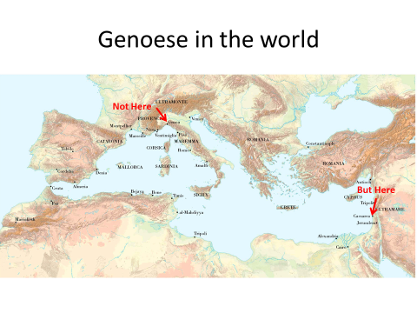 after all, the history of the city, by its own official medieval account, doesn’t even begin in Genoa, but with the sending out of 26 galleys and 6 ships to Caesarea, where, after installing a new king in Jerusalem and celebrating holy week in that city, the heroic Genoese scaled the walls of Caesarea using only the ladders of their galleys. After pausing to debate with two ‘Saracen’ representatives of the city whether Christian law allowed for killing at all, these ‘citizens and warriors of God’ conquered the city, and then sailed for home, carrying the spoils that God had given them as their reward—even the least of them received 48 soldi and 2 pounds of pepper. For many, this story is part of a key moment in which merchants, and the merchant mentality, become one of the great stories of European history.

In both my books, I too have focused on merchants as subject for comparison: if we look at the world through the eyes and actions of merchants—the people most likely to use and think about connections between places—will it permit us, I have asked, to see the geography of the medieval world as groups of medieval people in the Latin Christian and Islamic world might have seen it? And for one part of this talk I will indeed tell you some things I’ve learned about geography by looking at Genoese trade documents and how I'll be pursuing this research going forward. But I will also discuss why my question about merchants and approach to the sources has changed, and why the story the Genoese are telling about themselves needs to be read a bit differently.
What is and remains at the heart of both books is an inquiry into medieval geography as a problem in cultural as well as economic and social history. For a medieval Mediterraneanist, geography is a fundamental problem. To call one’s work Mediterranean is to implicitly join world or oceanic historians, such as Braudel or Horden and Purcell, who challenge narratives based on the outlines of modern nations. Thus I share the interests of many modern or early modern historiansin questioning whether the proper geographic boundaries of a subject are coincident with a political border. At the same time, as much as medieval historians know that the geography of the medieval world is not our geography, we struggle with the particular heritage of our field. For national divisions seemed obvious to the nineteenth- and twentieth-century historians who wrote much of the foundational scholarship and source projects that are still central to the study of medieval history. And many of these studies were written precisely in the service of writing the story of the medieval origins of European nation-states.
But at the same time, scholars who use the countering framework of ‘Mediterranean unity’ have yet to show they have done more than replace one modern construct with another. One of the main findings of my first book was to show that trade did not happen an undifferentiated or fully connected Mediterranean basin. Rather, regions were the central economic unit in the Islamic Mediterranean, great Islamic metropolises and their merchants organized and dominated highly integrated and vertically organized regional markets. It was from this position of regional economic dominance that they conducted specific inter-regional exchanges. Theories of ‘landscape’ or ‘ecological’ unity of the Mediterranean, whether Braudel’s ‘land of olive and vine’ or Horden and Purcell’s fragmented micro-ecology, I showed in this work, not only privilege European landscapes (esp. Greek and Italian), but in doing so radically deform our understanding of connections in the Mediterranean—they theoretically make marginal or ‘non-Mediterranean’ two of the areas that have historically been economically vital: the Nile Valley and Tunisian plain.
A focus on geography thus represents a methodological stance on my part—a way to approach sets of sources that does not presume in advance we know the boundaries of a subject. Part of the research process itself is to locate these connections and limits by tracing records of the movement of people and objects, and noting what is present and absent from the minds of actors when they talk about places and movement. For me, this has meant working back and forth between two ways of approaching medieval sources--first, building databases by extracting from sources the connections between locations, travels, objects, and people. Second, it has meant digitizing texts to use these patterns of data to look again at the language that describes places, or movement, or the geographic identities of people, to find new patterns and new things that need to be in the database, new things that might need to be mapped.
As an aside, I want to note that such tracing can mean drawing lines or marking places on a map, but that is to aid our comprehension of medieval actors, not a reflection of theirs. Indeed, one of the most difficult acts of imagination in my work is to erase the map in my mind, and accept that spatial thinking is a profound zone of medieval cultural alterity. None of the people I study thought with maps. Maps and visual images were not part of the imagination required to think about or plan economic activity, even over vast distances. I want to emphasize this exactly because one of Genoa’s claims to fame is the invention of the portolan chart—as thus to the map as part of their mastery of the world. But this is part of a different story of late 13th century Genoa.
In the eleventh and twelfth century, one reason to look hard at Genoa and Cairo is that the arrival of the Genoese fleet at Caeseara is generally read within a master narrative in which this is seen as the beginning of economic transformation in the Mediterranean, or even the western world. It is generally agreed that over the course of the twelfth century the Italian maritime-cities states, led by their merchant-adventurers, ‘captured the Mediterranean,’—with the most profound of consequences: it was the beginning of permanent decline for the Islamic economy, and the beginning of an economic revolution, the commercial revolution, in Europe. For the part of this narrative that about comparing development the Islamic and Christian worlds, I have shown that it depends on a false premise. That is, in order to support a narrative of decline, it supposes that Islamic merchants and states were economically dependent on transit trade, on taxing the profits of Saharan gold or Indian Ocean spices on their way to Europe. In this way, it is as though we still see the Islamic economy from the European gaze of Henry the Navigator or Christopher Columbus.
My first book showed how much historians have posed their questions about the Islamic economy from inside this master narrative, and how evidence from the Cairo Geniza undermines its basis. The commercial corpus of the Cairo Geniza is a trove of about 1500 papers—primarily letters, but also contracts, accounts, and other ephemera—associated with a linked group of businessmen active in both wholesale regional and long-distance commerce over the course of several generations in the eleventh and twelfth centuries. These documents come down to us because they were discarded in a synagogue in Cairo. Using these papers, I showed first that merchants in the Islamic world were not primarily dealing in transit goods: they actually devoted the bulk of their capital and energy to acquiring primary regional agricultural production and brokering it onto the Mediterranean market. And in their Mediterranean market, even where they were trading in those famous ‘gold and spices,’ they were not serving European customers—Europeans account for less than one tenth of one percent of the thousands of transactions recorded in these documents.
I first came to the documents of the Cairo Geniza as a historian of medieval Europe and Italy, and one of the main ways I think of myself as a comparative historian is that a great deal of the work I have done with Geniza documents has involved bringing and adapting the toolkit of medieval European history—including diplomatics, construction of typologies, and paleography—to everyday commercial documents, and bringing the questions of a more developed historiography on medieval European economies to examine the structure of the Islamic one. And now, I return to Genoa looking at it with Cairo eyes, which means two things: turning from asking what I can get out of sources that when they first came to historians' attention looked like this—
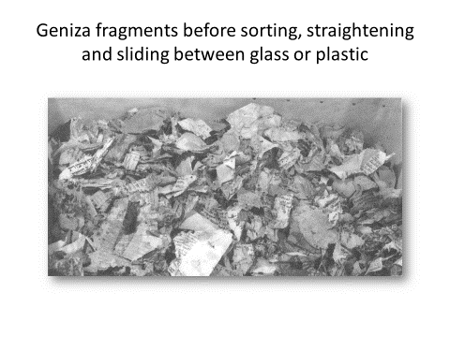because they were documents that were meant to be ephemeral, that come to us precisely because they were thrown away, to what new things we can learn from sources that are not just consciously constructed, a series of bound medieval volumes, but represent a very new and particular medieval way of collecting the past. And second, asking questions from the perspective of what I’ve uncovered about the Islamic Mediterranean economy,
For the ‘capture’ and ‘commercial revolution’ narrative also structures study of Genoa, taking for granted that twelfth-century Genoa, along with Venice, Amalfi and Pisa, took over the Mediterranean, and did so purposefully in the service of long-distance trade. Work on the Geniza has led me to ask whether the Genoese really ‘captured’ either 'the Mediterranean’ or ‘Mediterranean shipping.' And more, if the Italians did come to dominate transport, can we assume we know the economic implications? Long-distance trade in the Islamic world was inextricably connected to a regional economy, so what was the role of increased Italian shipping on long-distance trunk routes to the Islamic economy? And in turn, what was the relationship between local, regional, and long-distance trade for Genoa? Both questions ask how Genoese merchants were new players on the Mediterranean scene. Were they simply new competitors entering the market but doing the same things as Islamic merchants, or did they play a new and different kind of economic role?
But if one is interested in this master narrative, why ask these questions at Genoa rather than the other “maritime’ republics—Pisa, Amalfi, Venice? Medievalist shrugs and says “well, Genoa is the only one with really good sources.” But actually, if you are trying to look more broadly at changes in the Mediterranean geography and economy, Genoa is simply the most radical story. For even if we’re wary of seeing ‘firsts’ or ‘revolution,’ no denying that something astonishing happened here—this is a place of no consequence before the eleventh century, along a stretch of coast that had never, to our knowledge, been important before (in the ancient, classical Greek or Roman, or early medieval world). But in the eleventh century, though there are only a few mentions of them (the Genoesewere not yet collecting their own history), these find Genoese in Corsica by 1016, in Palermo in the 1050s, in Alexandria sometime in the 1070s, in al-Mahdiyya by 1087, and then in 1097-1110, the main naval support for the first Crusading armies and new Kingdom of Jerusalem. 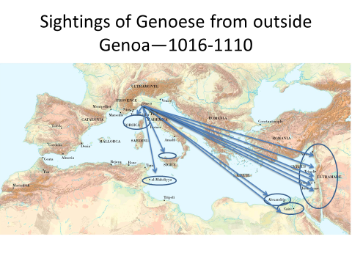
By the end of the twelfth century, they are to be found in every region of the Mediterranean, and by the end of the thirteenth, not only are they expanding to the Atlanic and Black Sea, but, as this is the first time we have enough comparative data to say anything, there’s a reasonable case to be made that this is the richest city in Latin Europe and would remain an important player in Med and European history, but especially economy, for centuries. 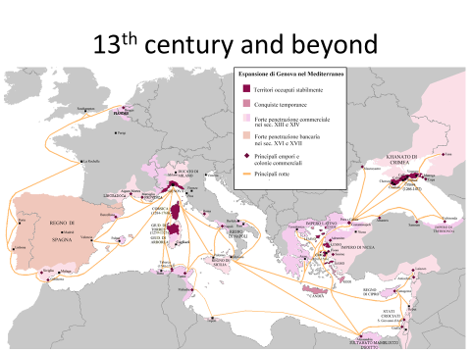 In this way (in fact in many ways), it is different from the other ‘maritime cities’ does not have much longer histories of Med. trade of Amalfi or Venice (whose economic emergence and importance is now known better from McCormick and Hodges), much faster and more permanent growth than neighboring Pisa. So in looking at Genoa, we are looking at how a new place emerges, becomes central, and changes the geographic patterns of the Mediterranean. And not only can we look at that process, but we have a unique ability to trace the Genoese vision of what was happening, because this was, as far as we know, the first medieval city in Latin Christendom to write and keep records of itself precisely ‘as a city,’ to collect and commission a public memory, to create a civic archive.
Indeed, because so much of what happens in Genoa seems so remarkable and so new in its medieval context, for over a century there have been scholars, from Sombart and Weber at the beginning of the 20th century to Braudel, Robert Lopez and Raymond de Roover in middle to Avner Greif and Douglass North at its end pointing fingers at Genoa (for different reasons and in different periods of the Middle Ages) as the place where capitalism, or perhaps the ‘pre-conditions of capitalism,’ or ‘the path to the modern Western economy’ begins. But though these are all interesting, and just as interesting are the reasons Italians tend to wince at them, since there are nearly as many theories for the economic ‘Rise of the West’ as there are for the ‘Fall of the Roman Empire,’ (and the former is certainly a growth industry), I will not wade into these just now.
I will wade into the question of Genoa’s expansion not from grand theory or master narrative but at the level of words—that is, constructing a database of the many ways geographic terms are used in the major sources we have for Genoa. A few of these are source types common to many medieval places, like the archives of the bishop/archbishop and the monasteries of the city. But though we would overlook such records at our peril, far more compelling are the records the twelfth-century Genoese either created from scratch, or very deliberately took out of the hands of their bishop who had kept them until then, or simply were the first to collect as of public interest. That means, in order, the city’s annals, the book of laws (not a law code—but a collection of legal documents, mostly charters securing rights and privileges from outsiders, treaties, but also internal statutes, rulings, and financial records), and most especially the notarial cartularies. These are bound paper volumes containing the notes, imbreviature, from an individual notary of all the contracts he was asked to prepare—part of a long tradition of Italian notaries, but sometime in mid-twelfth century, Genoa became the first place to require that these too be deposited in the commune’s archive. 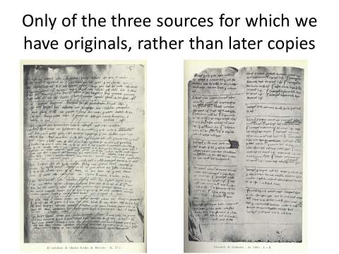
And because I expressed my interest as looking at mercantile geography, I began where many studies have begun: the destination Genoese individuals specified in the three kinds of contracts they wrote for trading ventures that involved travel. These were two kinds of partnership, the commenda and the societas, and the maritime loan. All three are essentially contracts between someone who proposes to travel for trade, and a non-traveling (sleeping) investor. The great majority of these contracts specify a destination for the voyage.
So it seems worth pointing out on a map all the places mentioned, broken down into temporal chunks that reflect the gaps and densities in our evidence--alas only some of the 12th century cartularies survive. There is one cartulary for the period 1155-1164, and then substantial evidence from 1182-1192, and after that continuously from 1198 on. So here’s a map for 1155-64, 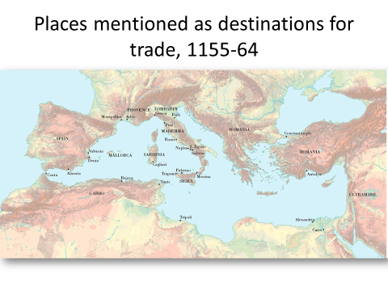 another for 1182-1192 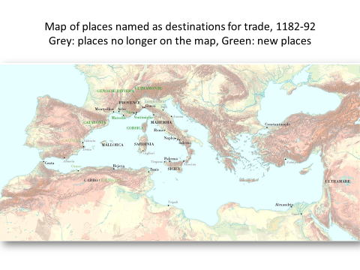 —in order to clarify part of change, I’ve turned places that have disappeared from the first cartulary grey, and put new additions in green, and then one 1198-1211 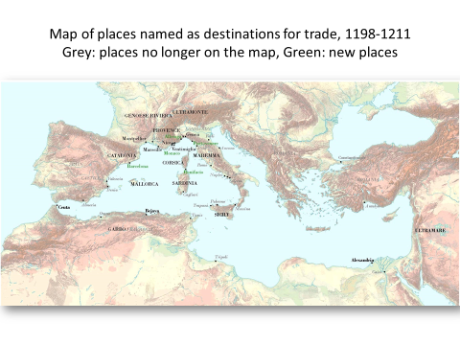. And though I want to talk about changes in the maps and what they mean, I want to first look at a consolidated map of places that appear in at least two of the three periods and more than once.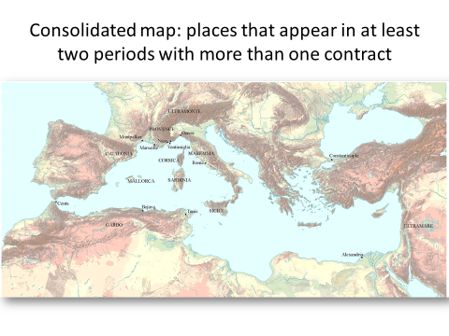
Why it is important to begin with this map.
For more than a century, economic historians have been collecting data about the number of contracts and total capital associated with different regions in order to sustain arguments about the nature or changing geography of medieval trade. A series of studies on particular regions (especially the Crusader Kingdoms) culminated in 1955 in the work of Erik Bach, who, while carefully noting all the methodological problems involved, nevertheless constructed a series of tables of regional trade in the 12th century. Scholars since have complained about some central problems with this work—mostly the very partial survival of twelfth-century cartularies and the fact that different notaries had different clientele, casting doubt on the representative quality of any for trying to determine proportional investment in different areas, and of course the fact that we know next to nothing about entirely personal investment rather than partnerships (aside from the fact that it existed). But as we know, statistical tables have a life of their own, so historians have nonetheless continued to either use, revise, or add to Bach’s work. In doing this work, scholars have noted certain limitations while ignoring other presuppositions and impositions. The most obvious is that only trade, and more specifically, only seaborne trade, is tabulated. This despite the fact that for the seven notaries from whom we have substantial parts of their cartularies, only somewhere between 17 and 35 percent of the contracts are for seaborne trade (though there is a slight upward trend). Second, geographically, each scholar has extracted and grouped information according to an imposed set of geographic categories—in a search for patterns in activity, they have ended up ignoring medieval evidence for whether and how patterns in thinking about geography of trade developed. Finally, scholars imposing this kind of geographic logic ignore what I find a central issue in understanding geographic practice, and the shifting understanding of the world of trade that lay behind it: patterns in specifying agent's movement: that is, naming multiple or alternate destinations, giving itineraries, requiring use of a particular boat, or, conversely, giving different kinds and degrees of freedom to traveling agents to change plans.
Immediate things study of Genoese destination language reveals.
First, a list of faraway places that were trading destinations had already crystallized before our first cartulary. The spelling of each place stable in each cartulary suggesting no confusion, and this striking because there is a great deal of instability in ways contracts are written (including multiple spelling of personal names). Second, the world does not get bigger in the geographic imagination—more people are recorded going far, but not to a larger number of distant places, in fact they are naming far fewer distant destinations.
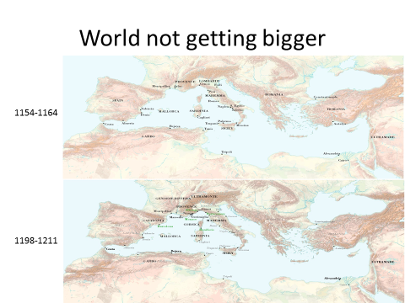
But if the language is stable, it is also, from a Geniza perspective, surprisingly jumbled—no distinctions are made between regional terms and specific cities—contracts just say a name. Coming from the Geniza, my sense of geographic order is upset: When Geniza merchants sent out goods in the central zone of their trade (the Islamic eastern Mediterranean), goods were sent to specific cities. Outside that zone, goods went to regions: balad al-Rum (land of the Romans), al-Andalus (Iberia), al-Gharb (the west, usually meaning Andalus and the western Maghrib). Market players, on the other hand, whose activities were often important to understand, were invariably described regionally: people talked about what the Maghribis (Tunisians), the Andalusis (Iberians), the Syrians, the Sicilians were doing.
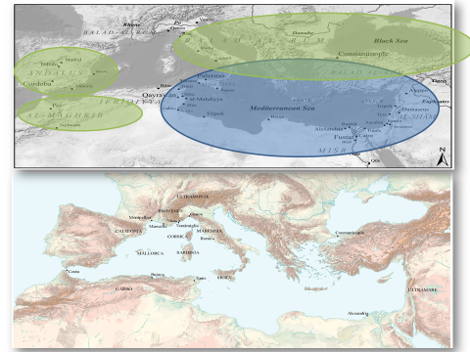
The other thing that’s interesting is that geographic terms are consistent but specific to Genoa: the smaller sample of contracts from Venice show them naming the same areas in different ways. Most obvious example is that the Genoese invariably use only the term ‘ultramare’ literally, across the sea, to talk about trade in the Levant, while the Venetians planning trade saw this either as a series of cities (Acre, Tripoli, Antioch, Jaffa) or as ‘Syria.’. Finally, this geographic vocabulary was specific, within Genoa, to trade. There are different names for the same places, and interest in quite different places, in the Annals and the laws.
The view from Cairo says the other obvious thing about this map is that there is no Genoese ‘capture’ of Mediterranean shipping. A table like those created by Bach and his successors suggests Genoese on every shore.
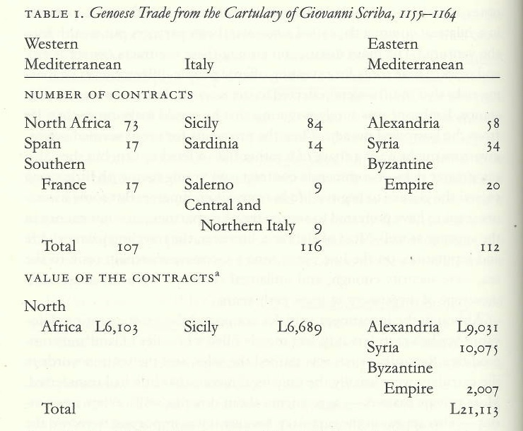
The map, however, suggests that the Genoese imagined trade with Islamic polities in a constrained and liminal way. If we compare it to my map of the Islamic world of trade, we see that they planned trips only to secondary or tertiary cities in the Islamic Mediterranean.
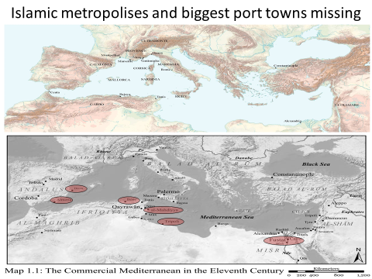This is not an outcome of technology, geography, or policies of exclusion— though some of the great metropolises were inland, the Genoese did not plan trade to the port metropolises of al-Mahdiyya or Cairo, and mostly not to the important ports of Almeria, Tripoli, or Bone. (And interestingly, only one trade to Tripoli even in period when it was under Norman rule) And my research shows how significant this liminality might have been, because merchants in the Islamic world profited in part from assuring that goods moved through the metropolis regardless of ‘natural’ geographic logic of connectivity. Nor does it seem the Genoese were unaware of where wealth was concentrated in the Islamic world: it is worth noting that their biggest military assaults against Islamic cities (aside from the First Crusade) were launched at al-Mahdiyya, Almeria, and finally Cairo. Thus no evidence that Genoese displaced Islamic shipping that linked metropolises, but instead suggests possibility of more complicated developments that I hope to explore more from the Islamic side—was this a complementary system, a compromise, an indication of Genoese inability to effectively penetrate the economies of the Islamic metropolises?
(slide 33) Looking back at changes in the maps, on the other hand, is an entrée into the nitty-gritty because it shows some significant change in the ways the Genoese as traders thought about spaces and the spatial organization of trade. But here a map alone misses much of the change. Because at least in first period 1155-64, a reading of the language of the cartulary makes it look like this:
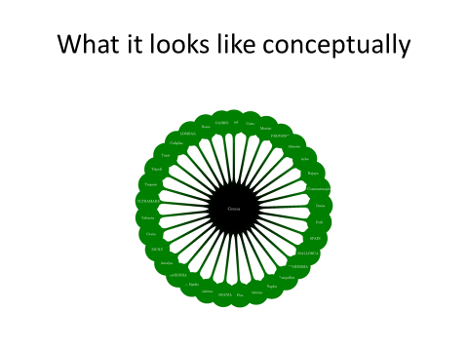
I say this because there is no indication of relative distance or relationship among destinations. This is revealed in a couple of ways: itineraries in contracts, relationship of contracts to one another, and specific language. In terms of itineraries, we thus find plans that look geographically sensible, but others that seem totally random: plenty of itineraries go Salerno to Sicily or vice versa, But what are we to make of the traveler in 1157 who agrees to go first to either Salerno or Alexandria, and then wherever he wants. Or the one in 1156 who is ordered to Valencia, and then, if most of the people in the ship agree, set off from there to Alexandria. Or a number of long and odd lists in the vein of this one from 1160: Spain first, then Sicily or Provence or Genoa, Provence to Sardinia or Genoa, Sicily to Genoa or Romania.
Equally, no pattern in specific conditions put on travelers that show distinction being made among places. This is mirrored by lack of coordination among contracts—not that many planned together, and even when planned near in time to same destination, differ in details of secondary destination, whether the traveler can go elsewhere, or whether the traveler needs to return to Genoa. I would argue the contradictory routes and language of contracts represent felt risks and a variety of ways to try and assure the return of capital, but in a rather disordered way. See this in three different strategies in contracts. First, many contracts, regardless of how near or far away the first destination, attempt to contractually control freedom of agent by specifying all allowable routes and destinations. Second, many contracts insists that the traveler, and not just the money (as is standard), return to Genoa Third, and less common, a trader agrees to travel only on a particular ship (majority of Venetian contracts). All of these used as a way to assert control over agent and contain risk, but these strategies are used at random, at least in terms of geography. Equally random geographically are a number of contracts that specifically allow the traveler choice-- after a first destination saying ‘or wherever he wishes/is able.’
When we can look in more detail again, after 1182, changes in both maps and language suggest increasing elements of order in planning, and more systematic thought about shape of world. Thus, we see large sets of contracts with identical destinations and terms and sometimes even watch the process of planning. In 1191, can watch voyages to Sicily, ultramare, and Constantinople all get organized at the house of William Crespini (member of one of the ruling clans), the first over a few days in March and the other two over several days in September, each involving dozens of individuals. A Much clearer distinction is made between the ‘near’ and the ‘far’--both in the map and contract specification. On the map, rather than an expanding list of places around Mediterranean that might suggest penetration of new markets or an adventuresome imagination, we have an increasingly reduced set of planned destinations (but with more trade recorded in each) that also speaks to more systematic naming of areas of world, and perhaps, a clearer sense of economic meaning of particular destinations—thus, contracts increasingly talk only of Sicily and not also Palermo, Messina, people travel to Constantinople—not also Romania. As the list of distant places shrinks, so the list of regional destinations expands, indeed we might say that in this naming the economic ‘region’ to which Genoa belongs takes shape.
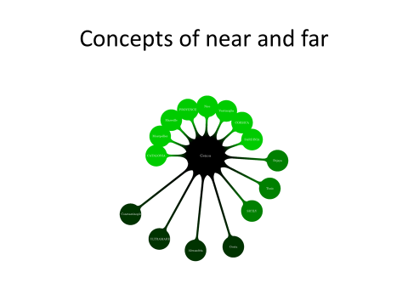
Equally, Contracts now have different meanings for these two kinds of travel, The 'near' and 'far'. It is now only those who travel nearby who are meant to return to Genoa. this is only this kind of trade that can be temporally and geographically managed by the investor in the city, with expanding list of particularized destinations, itineraries, or zones (coast as far as Provence, Corsica so long as first Bonifacio). On the other hand, more recognition of a ‘far’ where the traveler would have to be given the freedom to do ‘what he wishes,’ or ‘whatever seems better.’ And uncertain zone right in the middle: Sicily, Bejaya, Tunis, with Sicily in particular both near destination, a not-quite near destination, and sometimes a stopping place on the route east. Not quite this conceptually neat, because although freedom is almost universally accorded to agent going ‘far,’ and only ‘near’ require return to Genoa, but lots of contracts for ‘near’ and ‘middle’ that also entrust the traveler to make decisions, and there are still a handful of long-distance contracts that try and control the movements of agents.
So here the beginnings of a story take shape, in which we trace expansion not as engagement with ever more places in the world, but a new understanding of what different places and zones mean economically, a new organization of distance, time, and capital cycles. Can we see some sort of ‘merchant mind’ coalescing or becoming more dominant in trade as the century comes to a close? One aspect of my current work is tracing the persons, places, and objects of this proposed transformation.
But if it is exciting to uncover what seem to be real changes in ideas about the shape of the Mediterranean world of trade, it’s also puzzling that we find it happening so late. After all, we do have a mention in the Geniza of a ship from Genoa arriving in Alexandria that is datable to the 1070s, suggesting the Genoese had been active in long-distance trade for over a century by the time they develop this more orderly sense of the Mediterranean. And this leads to a different question: if we don’t assume it, can we know that the Genoese were primarily merchants, or thought primarily as long-distance traders, from the beginning of their Mediterranean expansion? In fact, were they primarily merchants or thinking as merchants when they took to the sea, even at the end of the 12th century?
A few reasons to think not trade records of the cartularies themselves: As I mentioned, coming from the Geniza, Genoese ideas of commercial space seem somewhat disorderly. But if we look at business techniques, they can seem downright primitive. The three contracts the Genoese used for long-distance trade were very simple, and resistant to development: the same basic contracts were used 1150-1270. And, the fixed division of profits, for instance, allows no distinctions in pricing labor, developing or rewarding expertise, a clear difference from Geniza contracts. Although the Genoese acquired possessions overseas, there is also remarkably little evidence of them using them to more effectively profit from trade in this period—ventures continued to send capital back to Genoa, no development of partnerships or residential agents that allow effective dispersion of capital into different markets and goods with different time horizons, timing of markets, again in stark contrast to Geniza merchants.
Further, examining the relation of non-trade contracts to trade contracts also suggests that two common theories to argue for the centrality of long-distance trade don’t pan out. Even though we all know that the plurality of contracts and capital was in real estate, scholars have argued first, that Genoese were using real estate trades to liberate capital for trade, and second, that those who ruled the city or would come to rule it were moving from agriculture into trade. Neither holds up: real estate transactions go from tiny to huge, but thus far I can’t find more than one or two instances of individuals at any size of transaction alienating real estate and then investing in trade, while members of families in the consular elite as a whole were increasing investment in real estate at greater rate than increase in trade. And a number of important families who are well represented in cartularies had little or no investment in trade. We have over 60 contracts for members of Doria family, and among them only a single trade contract to Sardinia. Perhaps the more notable in that the Doria owned ships and were often among leaders of Genoese fleets throughout twelfth century.
So suppose we cast aside this assumption, the idea that Italian maritime city-states were created ‘for and by merchants.’ If we do this, and then take the same methodology of tracing geography and geographic labels to one of our other great sources, the Annals of Genoa, we find the geography there--as I mentioned before--is rather different, even though the same individuals so often appear in both. (slide 43) And we need to consider the Annals carefully because the chronicle began as the personal project of one of the city’s most important civic leaders, Caffaro di Rustico, but were ordered to be properly re-copied and expanded as part of the city’s archives in 1152 and then continued to be commissioned and approved by the city for two centuries. They thus represent the city's own, conscious, and official record of its importance in the world. And for Caffaro and his official successors it was organized violence and the mobility of that violence, not trade, was the central mode of Genoa’s encounter with the world; official history occasionally celebrates important trade agreements, but is largely a story of Genoa’s interest in its own capacity for organized violence, the growing range of places it took that capacity, and the uses to which that violence could or should be put.
So if we turn back to the story I told of Caesarea, the beginning of Genoa’s history: We should note that history begins as a Crusade narrative, and it is actually the only major account of the First Crusade (there are about a dozen) to debate whether ‘killing’ and ‘taking’ are legitimate for Christians. In the account, the patriarch of Jerusalem comes to assure and demand of the Genoese three things: First, he tells them that killing is legitimate as vengeance and taking stuff as an act of recovering. But he goes further, promising that the spoils they will receive are as meant as God’s reward. Finally, makes a rather odd demand that in order to achieve their victory, the Genoese must abandon war machines and use only the ladders of their galleys to scale the city’s walls. This tells us that from the beginning that the Genoese were concerned about whether their violence was licit, and whether economic gain from violence was licit, and seemingly randomly, about whether the methods of their violence were licit. But equally, the economic reward of interest is spoils, and explaining spoils as God’s reward, is, I promise, a theme in Crusade narratives. The annals are not interested in the only fact usually recorded about Genoese participation in the Crusades: that the Genoese were also promised possessions in the conquered territories and indeed acquired the entire town of Byblos.
But from this point in the Annals, we’re off and running—the reader may quickly tire of the refrains of ‘and we had seven galleys and two ships against the Pisans near the mouth of the Arno, and we captured a thousand Pisans,’ ‘we had seven galleys and they had nine off the coast of Castagneto, but we captured their ships and brought them to Genoa,’ ‘we raided the city of Bejaya and took great spoils.’ But in these details and this geography of places is actually the story about violence that is the story of the ladders—an account of the ability of Genoa as a city, as a collectivity to organize violence as an end and honor unto itself. It is a paean, most especially, to their expanding and increasingly varied ability to move violence around the Mediterranean.
In the period of their First Crusade participation (1097-1110), their reach was long but capacity limited: the Genoese could provide themselves as sailor-warriors and some supplies to Crusade armies, but had no capacity to transport Crusade armies or serious war materiel over such a distance.The tale that the Genoese were ordered not to use towers and machines of war, but instead the ladders of their galleys, justifies a limitation. It is also in line with other Crusade narratives that record Genoese participation in siege of Jerusalem, in which two Genoese leaders broke up their ships for wood to use for building siege engines, having no other supply. We can watch the Annals celebrating growing abilities and reach as the century progresses. In 1118 and again in 1126, Caffaro justly celebrates ability to transport not just Genoese infantry but the horses and equipment for knights for a battles near the coast of Pisa. And we might note that this was an important technological accomplishment in the period--Bayeux tapestry takes a fair bit of time to celebrate this special transport prowess of the Norman invaders in 1066.
By 1140s, he details how they were able to transport full-scale battle equipment—infantry, mounted knights, materials to build war machines for land war over increasing distances—all the way to Minorca and Almeria. In 1161, the annals records the first example of a ‘wise Genoese leader’ ensuring that galleys could patrol a zone of the sea for ships (whole area of Corsica and Sardinia as far as Denia), not just patrol the sea to prey upon other ships. By 1190, fully capable of contracting with Philip of France to transport and supply his entire Crusading army. And in a testament to attitudes, in 1154, the fact that there had been no sending or fleets or battles to report for five long year provokes the annalist to complain that the city was asleep, and required the archbishop to cleanse them of their sins, at which point they re-dedicated themselves to the honor of the city, and thinking of how best to pursue it, set to building war galleys.
Thus, I’m still studying the shape of the world from the perspective of the Genoese, but no longer taking for granted that I’m necessarily looking through the eyes of merchants, or that Genoa had a single way of looking at the world. Long-distance trade was always part of Genoese activity in the Mediterranean, so too was organized violence. To understand the role trade played in economic growth, in geographic expansion, in the nature of Genoese society, or, especially, in Genoese ideas of their identity and place in the Mediterranean means re-examining what was important to the Genoese: when, and to what degree, did they become merchants, who saw the world through merchant eyes and how often? The most famous Italian tag for the Genoese, after all, is ‘januensis ergo mercator’ Genoese and therefore a merchant, but no one knows quite when it came into being. The cartularies, however, tell us that however much they recorded plans for trade, it took a long time for merchant identity to form: in records that are full of professional labels, no one from Genoa named himself as a merchant in a contract before the end of the 13th century.

In looking at patterns and disparities in contract specification, I am trying to understand whether this change is general, or whether we can watch individuals or families (like Crespini) emerge as organizers by comparing investment patterns of individuals or families from period to period. Equally, by tracing relationships among individuals and activities, I am studying whether patterns in allowing freedom to agents involves a spatial sense of risk or the risk posed by the person of the traveler and his relations to the investors

