Leon Balents
Kavli Institute for Theoretical Physics
University of California

Dr. Leon Balents is a theoretical physicist and a permanent member of the Kavli Institute of Theoretical Physics at the University of California, Santa Barbara. He studies the quantum physics of the vast numbers of electrons and atoms living inside solid matter.

Dr. Balents is especially known for his work bridging abstract mathematical theory and the complexities of materials. He is one of the world’s experts on exotic magnets that show quantum behavior on macroscopic scales. He co-discovered and named “topological insulators”, a new class of solids which conduct electrically on their surface extremely well, and may lead to new types of devices. He dreams of understanding electrons well enough to eventually design new phases of matter.

After getting his PhD from Harvard University, Dr. Balents was a postdoctoral fellow at the Institute for Theoretical Physics in Santa Barbara, and then worked in the research laboratory of Lucent Technologies, Bell Laboratories. He returned to Santa Barbara as a member of the Physics Department in 1999, and in 2008 moved to the Kavli Institute for Theoretical Physics where he works now. Dr. Balents has received several fellowships, and is a Fellow of the American Physical Society.
Particles, Quasi-particles,
and Beyond

Physicists talk about particles all the time. Recently there was a lot of excitement over the discovery of the Higgs boson, the last "elementary particle" which was up until last year missing from the Standard Model of subatomic physics. In this talk, he’ll explain what a physicist means by an elementary particle, and how more often we deal with particles that are not elementary. “Quasi-particles" are actually the crucial objects that are used to describe the quantum behavior of matter, not just in giant particle accelerators but in ordinary materials you can hold in your hand. There are simple and exotic quasi-particles, and even situations in which there are no quasi-particles at all. I'll present and explain some examples, and describe how these ideas intersect frontiers of research in physics.

Beginning Sunday, Grassroots TV, Comcast Channel 12 Aspen to El Jebel, or Channel 82 Carbondale to Glenwood, will broadcast this lecture and/or an interview with Dr. Balents:

Sunday 1:30pm Preview, 2:00pm Lecture
Monday 5:00pm Preview
Tuesday 8:00am and 11:30pm Previews
Wednesday 10:00am Preview, 10:30am Lecture
Thursday 9:30pm Preview, 10:00pm Lecture

Our winter lecture series is graciously sponsored by the

Nick DeWolf Foundation, which has also archived all past lectures at www.aspenphys.org, and at grassrootstv.org. Search by dates or speakers’ names.

2014 Maggie & Nick DeWolf

FREE Physics Lectures

Wheeler Opera House
4:30 to 5:30 PM Physics Café co-hosted with Aspen Science Center
5:30 to 6:30 PM Lecture

Wed, January 8 Superconductivity: Magic and Mystery
Louis Taillefer, Sherbrooke Univ & CIFAR

Wed, January 15 Particles, Quasi-particles, and Beyond Leon Balents, KITP

Wed, January 22 Higgs Boson: A Natural Disaster!
Kyle Cranmer, New York Univ

Wed, January 29 Swimming in Syrup: How Do Bacteria Move?
Kenny Breuer, Brown University

Wed, February 5 Astrophysics
TBD

Mon, March 10 Condensed Matter
TBD

Tues, March 18 Particle Physics*
TBA
Please email patty@aspenphys.org to receive updates and announcements. Listen to local high school students interview physicists on KDNK! Radio Physics airs the last Tuesday of every month at 4:30 PM.

The Aspen Center for Physics is supported by
the National Science Foundation Grant #PHY-1066293.
This Winter Conference, Beyond Quasiparticles: New Paradigms for Quantum Fluids, is also sponsored by the Moore Foundation.

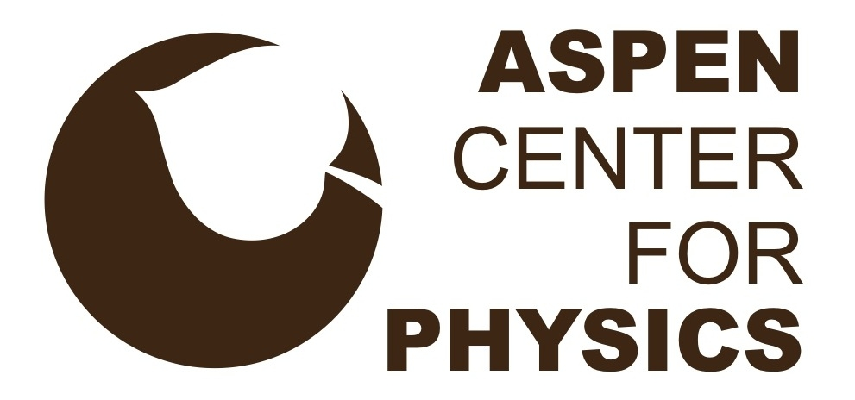

Particles, Quasi-particles,
and Beyond
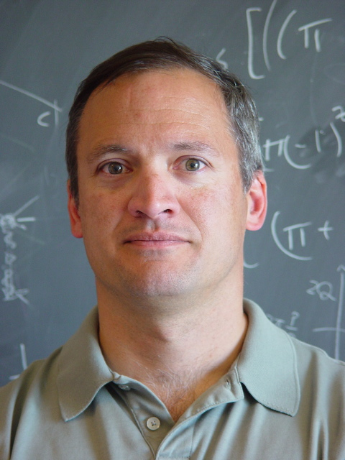
Leon Balents
Kavli Institute for Theoretical Physics
University of California

Aspen Center for Physics
700 West Gillespie Street * Aspen, CO 81611
970.925.2585
www.aspenphys.org * acp@aspenphys.org

