Bi10 Prelab #8
Any questions regarding this prelab should be addressed to dlu2@caltech.edu
- State the full name (if given an acronym) and purpose of each of the reagents used in SDS-PAGE:
  - SDS (1 point)

  - DTT (1 point)

  - TEMED (1 point)

  - APS (1 point)

  - Coomassie blue (1 point)

- Please describe or draw what happens if you do the following and explain why this happens:
  - You only made the running gel, but not the stacking gel, ran SDS-PAGE on this gel, and stained the gel for proteins (3 points). What are the differences between the stacking gel and the running gel? (2 points)

  - You poured the polyacrylamide gel the way you poured the horizontal agarose gel. (2 points)

  - You mixed a sample with proteins with a variety of different sizes in the loading buffer you would normally use for SDS-PAGE (and heated the sample properly) but ran the sample in a 1% agarose gel instead of a polyacrylamide gel. (2 points)

- The sculpture fountain in Beckman Institute courtyard represents ferritin, a protein that stores iron in cells. Ferritin is made of heavy chains and light chains. Ferritin light chain has molecular weight 20,020 Da (human, Uniprot).
  - What does the unit Dalton mean? (1 point)

  - Why are there bands in the ladder that are not blue? (1 point)

  - Suppose you have purified ferritin light chain, ran the purified protein in SDS-PAGE, and stained the gel. Please draw where you would see the band for this protein in lane 1 below. (1 point)
Lane 1 Lane 2 Lane 3 Lane 4
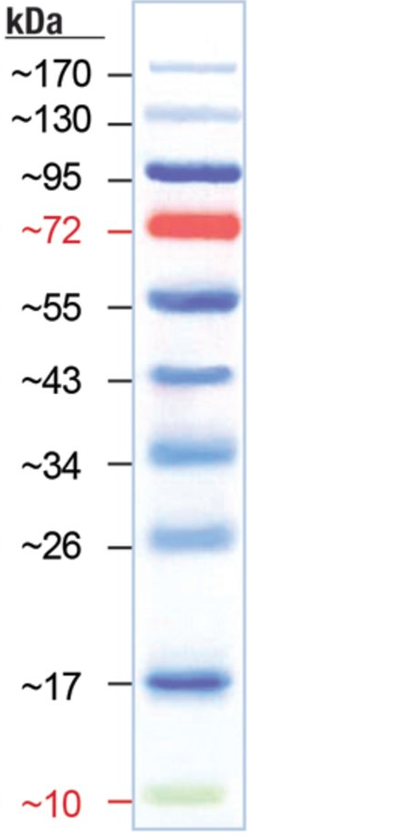
- Draw above what you would see on a gel if you do the following in SDS-PAGE and then stain the gel:
  - Lane 2: You have a purified protein that has 2 separate amino acid chains, normally linked together by a disulfide bond. There’s no quaternary structure. You run the proper SDS-PAGE with SDS and DTT. Chain 1 is about 15 kDa, and chain 2 is about 50 kDa. (2 points)
  - Lane 3: You have the same protein as in part a, but you didn’t put DTT, assuming that tertiary structure didn’t significantly affect the speed the protein travels through the gel. (2 points)
  - Lane 4: You have a protein (no tertiary or quaternary structure) that can be phosphorylated on one tyrosine residue. The molecular weight (unphosphorylated) is around 30kda. Your sample contains both the phosphorylated and the unphosphorylated forms. Please also label which band is the phosphorylated form. (2 points)
- When you run a protein in polyacrylamide gel with SDS and DTT, you get 2 bands, but when you run the same protein in the same gel without SDS but with DTT, you only get one band that has larger molecular weight. What does this say about the structure of this protein? (2 points)

